Six knowledge points:
1 What is the role of Architectural design?

2. Please analyze the following architecture of a packing robot control system.
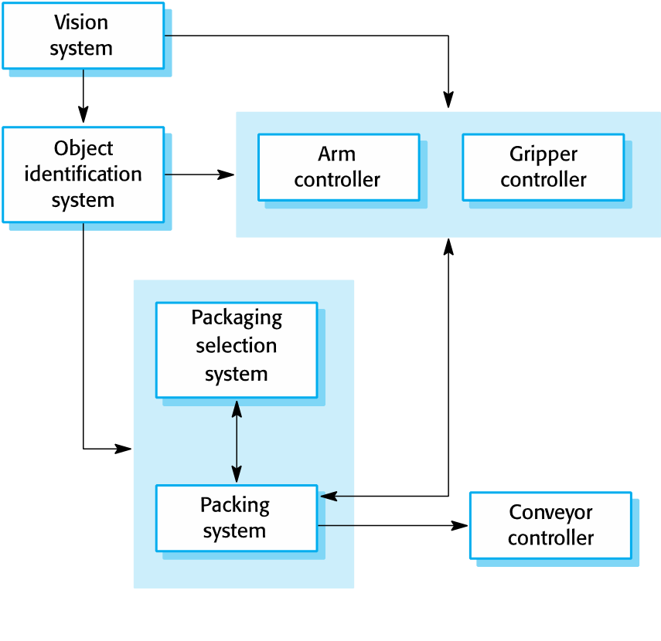
3. Please describe 8 common decisions for Architectural design.

4. What are the five Architecture and system characteristics?

5. Please describe four kinds of Architectural views?

6. Please give some examples for Architectural patterns including MVC, Layered architecture, Repository architecture, Client-server architecture, the pipe and filter pattern.

